Homework Assignment Week 2
Objective:
- Be able to declare variables and assign values to it
- Be able to take input from user
- Be able to convert value of one data type into another
- Use math operators and write expressions
- Be able to print the values on output screen

Instructions:
- Name your python file as HW_W2_{yourFirstName}{LastNameInitial}.py
For example: Michael K will name the python file of homework assignment Week 2 as HW_W2_MichaelK.py
- Write the Python code for either Problem 1 or Problem 2
- The code should only use Python commands that have been covered in the course up to this point.
- You will record a small video (3-5 min) to explain the code you wrote for the assignment. For learning how to create a recording in Zoom, refer to document ‘How to record video presentation using Zoom’ in D2L Content -> How-To Guides
- Submit both, .py file and the video, in D2L Assignments -> Homework Assignment Week 2 Dropbox. Refer to the document ‘How to submit homework assignment with video presentation’ in D2L Content -> How-To Guides.

Grading Rubric:

The grading rubric is as shown below. You can also find this rubric in D2L under Homework Assignment Week 2.

15 points are assigned for the Python file submitted

10 points are assigned for the video presentation
- Refer to the document ‘Coding Assignment Checklist’ in D2L Content -> How-To Guides to make sure you meet all the grading requirements

Code Submission Rubric (15 Points)
Criteria | Full Points | Partial Points | No Points | Score
Code Syntax & Output Accuracy (4 pts) | 4 pts: No syntax errors; code runs; correct output | 2 pts: Minor errors OR incorrect output | 0 pts: Code doesn't run OR no output | /4
Code Implementation (3 pts) | 3 pts: Follows instructions and uses taught concepts | 2 pts: Partial or uses untaught concepts | 0 pts: Does not follow instructions | /3
Comments & Documentation (3 pts) | 3 pts: Clear comments for purpose, variables, logic, output | 2 pts: Some comments missing | 0 pts: No comments | /3
Style & Readability (3 pts) | 3 pts: clean formatting, indentation, good naming | 1 pt: Poor spacing or naming | 0 pts: Poor formatting | /3
File Naming (2 pts) | 2 pts: Correct file name | 1 pt: Partially correct | 0 pts: Incorrect name | /2

Video Presentation Rubric (10 Points)
Criteria | Excellent | Good | Needs Improvement | Score
Code Explanation (3 pts) | 3 pts: Step-by-step explanation, clear terminology | 2 pts: Partial explanation | 0 pts: No explanation | /3
Demonstration (3 pts) | 3 pts: Runs correctly with all tests | 2 pts: Runs but incomplete tests | 0 pts: No run or incorrect | /3
Reflection & Challenges (3 pts) | 3 pts: Explains challenges and learning | 2 pts: Limited reflection | 0 pts: None | /3
Communication Skills (1 pt) | 1 pt: Clear, organized, within time | 0.5 pt: Some issues | 0 pts: Hard to follow | /1

How comments can be written in the code:

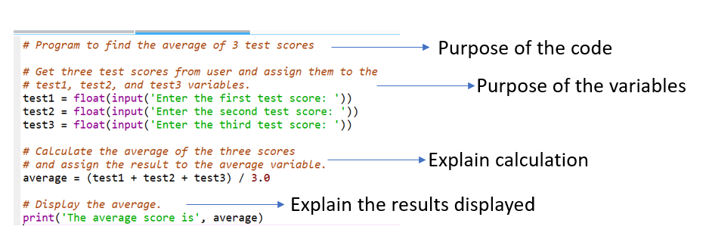

Problem1: Celsius to Fahrenheit Temperature Converter
Write a program that converts Celsius temperatures to Fahrenheit temperatures. The formula is as follows:
$$F=\left(\frac{9}{5}\right)C+32$$
The program should ask the user to enter a temperature in Celsius, and then calculate the temperature in Fahrenheit. The calculated Fahrenheit temperature should be formatted to display a maximum of 2 digits after the decimal point. Refer to pseudocode after expected output if required.
Expected Output:
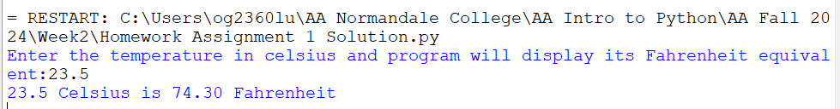
Pseudocode
- Take Celsius temperature input from the user
- Convert it to the appropriate data type
- Store it in a variable
- Apply the formula to convert Celsius temperature to Fahrenheit
- Store the Fahrenheit temperature in a variable
- Display the Fahrenheit temperature with 2 digits of precision
Problem 2: A bag of cookies holds 40 cookies. The calorie information on the bag claims that there are 10 servings in the bag and that a serving equals 300 calories. Write a program that lets the user enter the number of cookies he or she actually ate and then reports the number of total calories consumed. Note: You need to have variables for total cookies in bag, total servings in the bag and calories per serving and do the calculations using the variable names. Refer to pseudocode after expected output if required.
Expected Output:
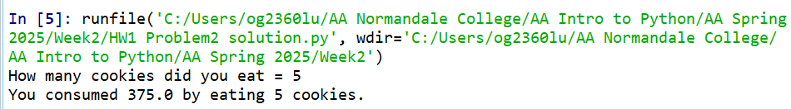
Pseudocode
- Variable to hold total number of cookies
- Variable to hold total servings
- Calculate cookies per serving.
Formula: cookies per serving = (total number of cookies / total servings)
- Variable to hold total calories per serving
- Calculate calories per cookie
Formula: calories per cookie = (total calories per serving / cookies per serving)
- Ask user how many cookies he/she ate
- Store user input in integer variable called 'cookiesUserAte'
- Calculate total calories consumed by user
Formula: total calories consumed by user = calories per cookie * cookiesUserAte
- Print the total calories consumed by user

